**SQL- Case Study**

“Richard’s Supply” is a company which deals with different food products. The company is associated with pool of suppliers. Every Supplier supplies different type of food products to Richard’s supply. This company also receives orders for the food products from various customers. Each order may have multiple products mentioned along with the quantity. The company is maintaining the database for 2 years.

Refer to the following Entity-Relationship diagram of the database.

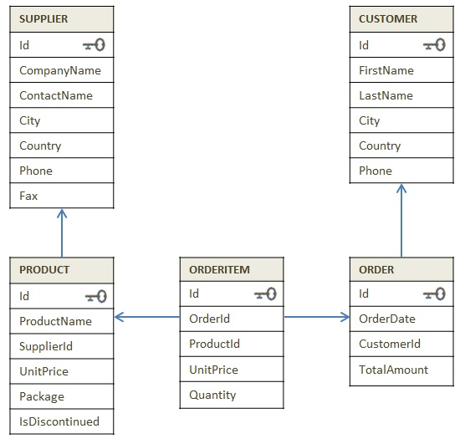

Diagram: E-R Diagram of Supply_chain database

Try to get insight of business through the dataset

**Instruction:** Execute the SQL files in the sequence given below.

1. 1_DDL_Case Study
2. 2_Data
3. 3_Data Constraints

**Section B --> Know the business**

1. Arrange the product id, product name based on high demand by the customer.
2. Display the number of orders delivered every year.
3. Calculate year-wise total revenue.
4. Display total amount ordered by each customer from high to low.
5. A sales and marketing department of this company wants to find out how frequently customer have business with them. List the current and previous order amount for each customer.
6. Find out top 3 suppliers in terms of revenue generated by their products.

**Section C --> Business Analysis**

1. Display all the product details with the ordered quantity size as 1.
2. Display the compan(y)ies which supplies products whose cost is above 100.
3. Create a combined list to display customers and supplier list as per the below format.

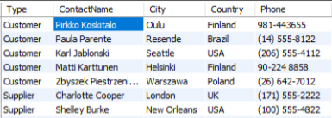

**Section D --> Challenge**

1. Company sells the product at different discounted rates. Refer actual product price in product table and selling price in the order item table. Write a query to find out total amount saved in each order then display the orders from highest to lowest amount saved.
2. Mr. Kavin want to become a supplier. He got the database of "Richard's Supply" for reference. Help him to pick: few products that he should choose based on demand.
3. Every supplier supplies specific products to the customers. Create a view of suppliers and total sales made by their products and write a query on this view to find out top 2 suppliers(using windows function RANK () ) in each country by total sales done by the products